**WEEK 5- LAB 6(WEBAPI)**Kafka: zookeeper  
  
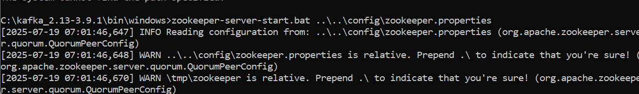  
  
Kafka server start

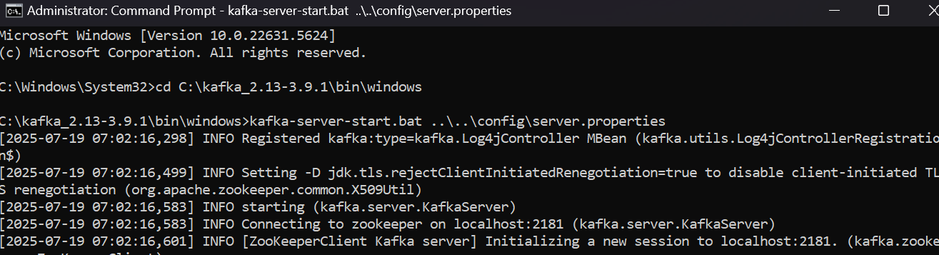  
  
Chat sender side

using System;

using Confluent.Kafka;

class Program

{

static async Task Main()

{

var config = new ProducerConfig

{

BootstrapServers = "localhost:9092"

};

using var producer = new ProducerBuilder<Null, string>(config).Build();

Console.WriteLine("=== Kafka Chat Producer ===");

Console.WriteLine("Type your message and press Enter. Type 'exit' to quit.");

while (true)

{

Console.Write("You: ");

var input = Console.ReadLine();

if (input.ToLower() == "exit")

break;

await producer.ProduceAsync("chat-topic", new Message<Null, string> { Value = input });

}

}

}

Chat reciever

class Program

{

static void Main()

{

var config = new ConsumerConfig

{

GroupId = "chat-group",

BootstrapServers = "localhost:9092",

AutoOffsetReset = AutoOffsetReset.Earliest

};

using var consumer = new ConsumerBuilder<Ignore, string>(config).Build();

consumer.Subscribe("chat-topic");

Console.WriteLine("=== Kafka Chat Consumer ===");

Console.WriteLine("Waiting for messages...");

while (true)

{

var cr = consumer.Consume();

Console.WriteLine($"\nFriend: {cr.Message.Value}");

}

}

}

